**Project Initialization and Planning Phase**

| Date | 01 October 2025 |
| --- | --- |
| Team ID | SWUID20250215169 |
| Project Name | Global Food Production Trends and Analysis:  A Comprehensive Study from 1961 to 2023 Using Power BI |
| Maximum Marks | 3 Marks |

**Define Problem Statements (Customer Problem Statement Template):**

Create a problem statement to understand your customer's point of view. The Customer Problem Statement template helps you focus on what matters to create experiences people will love. A well-articulated customer problem statement allows you and your team to find the ideal solution for your customers' challenges. Throughout the process, you’ll also be able to empathize with your customers, which helps you better understand how they perceive your product or service.

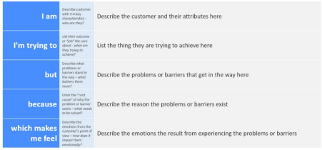

Reference: https://miro.com/templates/customer-problem-statement/

**Example:**



|  |  |  |  |  |  |
| --- | --- | --- | --- | --- | --- |
| **Problem**  **Statement (PS)** | **I am**  **(Customer)** | **I’m trying to** | **But** | **Because** | **Which makes me feel** |
| PS-1 | A global policy analyst or researcher | Understand long-term global food production patterns and identify key contributing regions and crops | The available data is vast, inconsistent, and difficult to interpret manually | The datasets span multiple decades (1961–2023) and contain varying regional and crop-level details | Overwhelmed by the complexity and unable to extract actionable insights quickly |
| PS-2 | A data-driven decision-maker or agricultural planner | Visualize production trends, compare regions, and identify the fastest-growing crops | Traditional data reports and tables lack interactivity and real-time analytical capabilities | They do not provide dynamic filtering or comparative insights through visuals | Frustrated by static reports that hinder quick and data-backed decision-making |